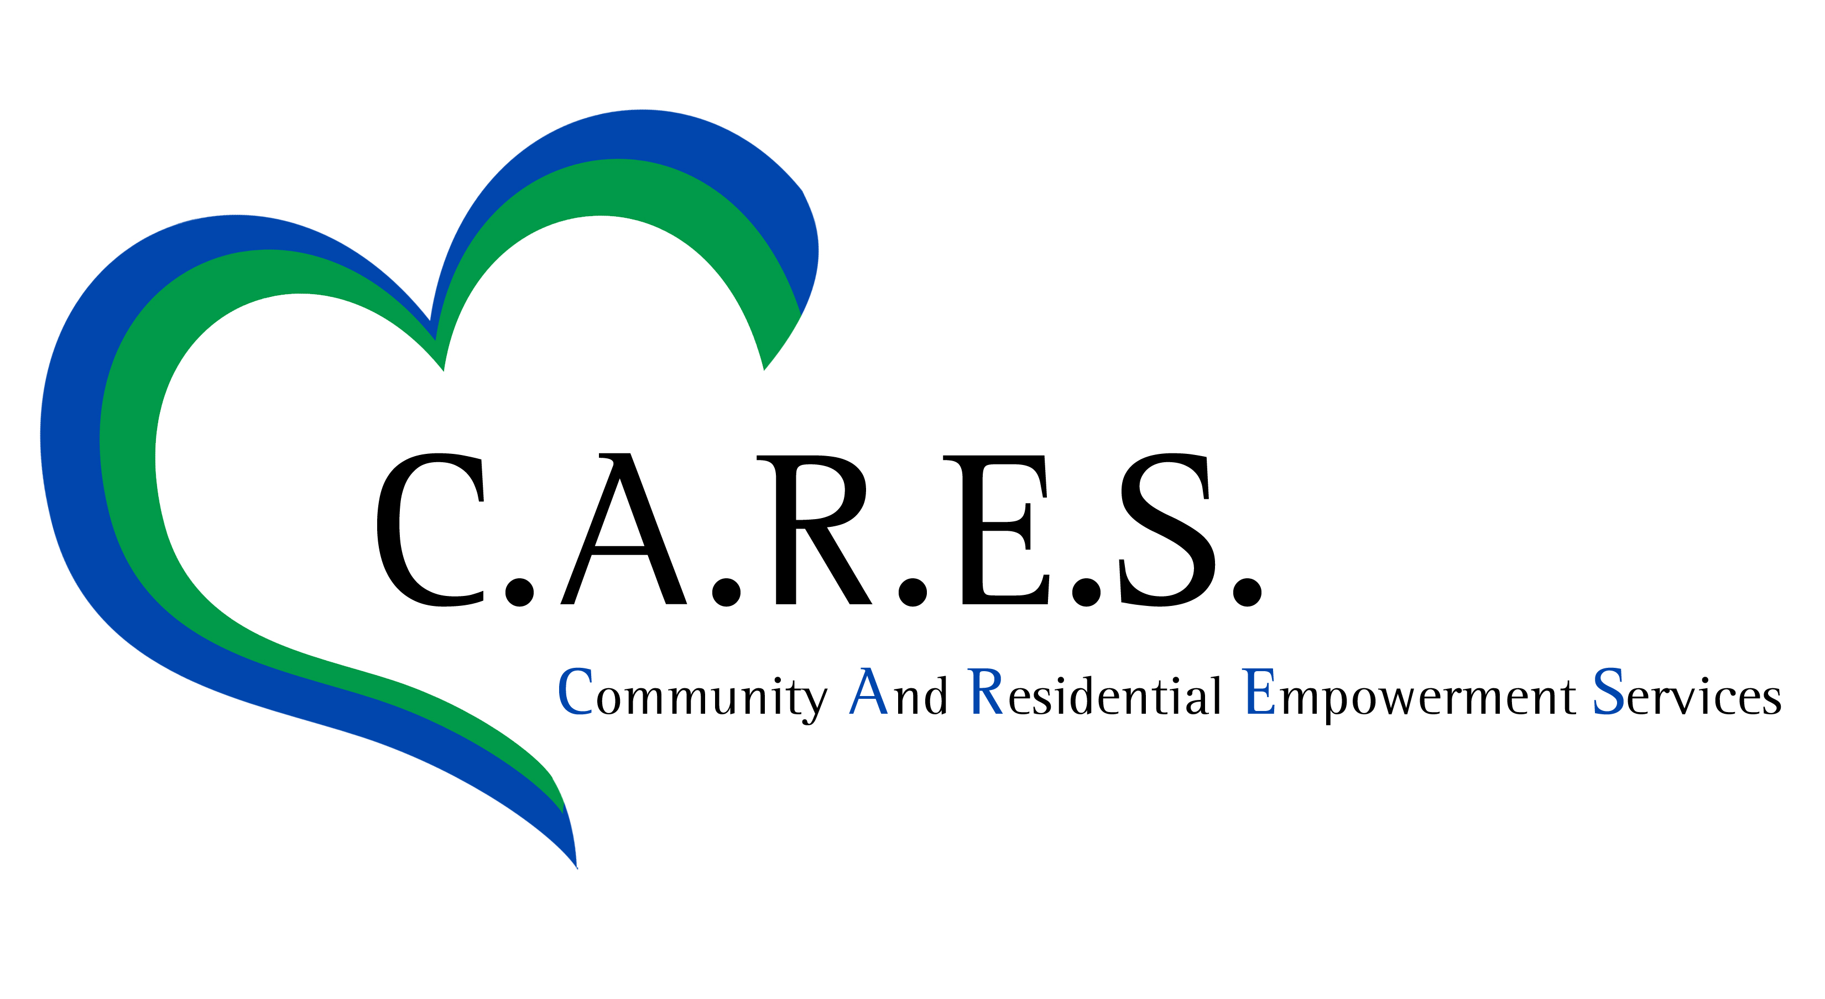Community based day ProgramS

C.A.R.E.S. is excited to announce the opening of three new Monday through Friday, all-inclusive community based day programs in Northeastern and Central PA! C.A.R.E.S. Day Programs provide participants with a choice of many volunteer opportunities and recreational activities to enhance the participants’ life skills, social skills and prevocational skills. Participants enjoy volunteering for non-profits such as food banks, animal shelters and Meals on Wheels. Recreational activities, such as nature centers, amusement parks, bowling, and zoos are also included at no extra cost to participants! To maximize opportunity and safety we offer a 1 staff per 3 participants ratio. Door to door transportation is offered by C.A.R.E.S. employees in company vans.
NOW ACCEPTING REFERRALS!
Christ Lutheran Church
189 Church Road
Jim Thorpe, Pa
St. John Lutheran Church
216 n. McAllister St
Bellefonte, Pa

Christ Episcopal Church
205 N. 7th Street
Stroudsburg, Pa

for more information contact: Marsha Macalush @ 570-249-4777

